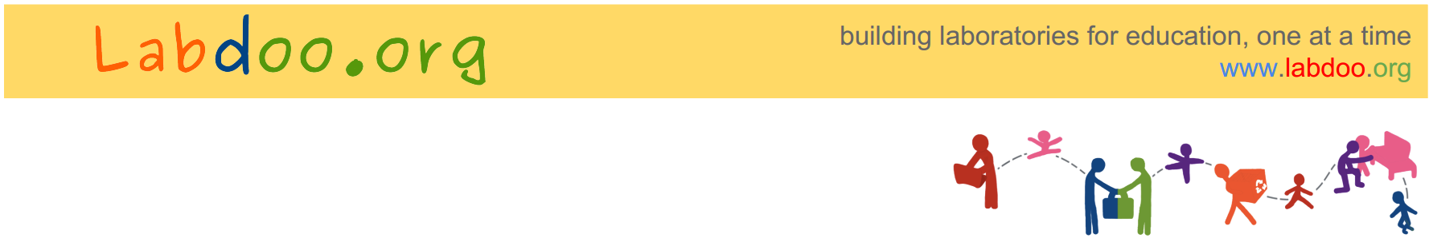

To Whom It May Concern:

This letter is to confirm that will be traveling to from __________
on bringing used laptops. These laptops are a donation and will be used to teach computer skills and provide access to education at the school project “ ", located in .

The list of laptops is as follows:

[
for example:
http://www.labdoo.org/laptop/000001000
http://www.labdoo.org/laptop/000001001
http://www.labdoo.org/laptop/000001002
]

Labdoo is an open project that focuses on bringing laptops to schools around the globe. Labdoo laptops are sanitized by a global network of volunteers and include open source education software to help educate children. To avoid environmental costs, all laptops are used (not new) and are transported from one location to another using a network of volunteer travelers. All Labdoo laptops are provided free, they are not for commercial use, and they are only deployed in schools and education centers.

Yours truly,

Labdoo Team
[DATE]

